**Reddit Data Documentation**

**Tate_all.csv**

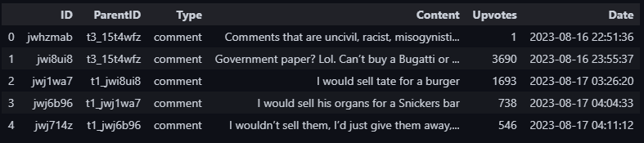

**Type –** comment or reply

**Content –** Title or text of the submission / comment

**Upvotes –** Comment Score

**Date -** %Y-%m-%d %H:%M:%S

**How the Comment Thread is Listed:**

* **Type** = submission
* **Type** = comment & **ParentID** corresponds to **ID**: top-level comment
* **Type** = comment and **ParentID** corresponds **ParentID**: This is a reply to another comment.

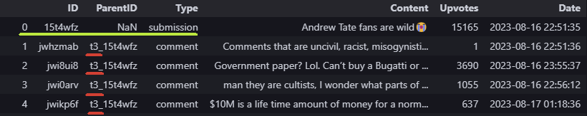

[0] is a submission

[1-4] are replying to the submission (t3_)

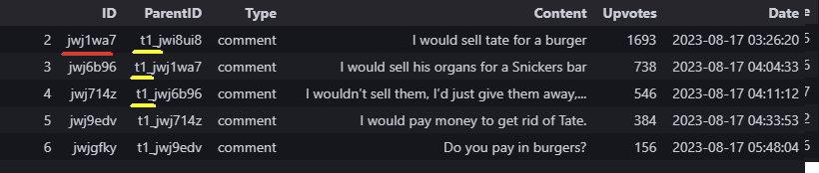

[2] is a reply (t1_)

[3] is replying to [2]

**Code**

tempdf = pd.read_csv('Tate_all.csv')

submission_id = '15t4wfz'

# submission rows

submission_row = tempdf[tempdf['ID'] == submission_id]

#top-level comments for submission

top_level_comments = tempdf[tempdf['ParentID'] == 't3_' + submission_id]

# IDs of top-level comments

top_level_comment_ids = top_level_comments['ID'].tolist()

# replies to top-level comments

replies_to_top_level_comments = tempdf[tempdf['ParentID'].isin(top_level_comment_ids)]

# Concatenate the submission row, top-level comments, and their replies

result_df = pd.concat([submission_row, top_level_comments, replies_to_top_level_comments])

# Reset the index

result_df = result_df.reset_index(drop=True)

result_df

